## 1. Program introduction

|  |  |  |
| --- | --- | --- |
| **Program script** | **Introduce** | **Rely on** |
| ***allrun.m*** | Execute " ***csisp_ledlag.m***" for all ***delta*** parameters_ And save the data | ***csisp_ledlag.m***  ***fit_test.m*** |
| ***csisp_ledlag.m*** | Calculate the following relationship of stocks | Data：  “**matrix_csi_09-20.csv**”  “**matrix_sp500_09-20.csv**” |
| ***f*it_test.m** | Fitting power law distribution | ***fit_find_opts.m*** |
| ***fit_find_opts.m*** | Find the optimal power law distribution |  |

## 2. Output introduction

**（1）allrun.m**

Execute **csisp_ledlag.m**, and **fit_test.m**.

The results of **csisp_ledlag.m** are saved automatically

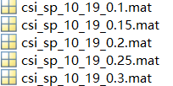

(Represents different **delta** execution results)

**fit_test.m** is saved in **output3**.

Output3 is a 5 * 6 * 2 matrix

5 delta values,6 power-law distribution settlement results, 2 stock markets



By executing the code

**CSI=Output3(:,:,1);**

**SP=Output3(:,:,2);**

The power-law distribution fitting results of different markets under different delta values can be extracted

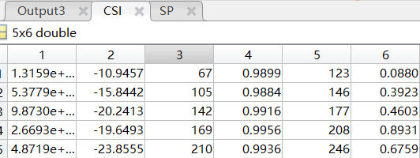

$$y=ax^{e}$$

The first column of data is **a** value, the second column is **e** value, and the sixth column is p**-value** of KS test, corresponding to **table 2** in the paper. Due to the initial value setting and calculation accuracy, the results will be slightly different, but it does not affect the conclusion.

**（2）csisp_ledlag.m**

The results of the procedure are mainly as follows



It stores the cumulative number of days that two stocks follow (matrix asymmetry)

Statistics of the following probability results of different cumulative days in the two markets are shown in Figure 5 of the paper

